Département de Génie Informatique et Communication

Department of Information and Communication Engineering

Topic : TP12

CRUD APIs, Mongoose, Admin Dashboard

Subject : Internet Programming

Teacher : Mr. Hok Tin

Name : YORNG TONGHY

ID : e20191313

Group : I4-GIC-C

Year : 2022-2023

Table of Contents

Exercise 1: Express JS 3

- CRUD APIs for Price 4

- Create Price 4

-Get Price 4

-Update Price 5

-Delete Price 5

Exercise 2: VueJS 6

o Login View 6

o Management 6

- Category 6

- Sub Category 7

- Product 7

o Creation 8

- Category 8

- Sub-Category 8

- Product 9

o Update 9

- Category 9

- Sub Category 10

- Product 10

o Delete 11

- Category 11

- Sub Category 11

- Product 12

Github Link: <https://github.com/yorng-tonghy/IP-TP08-TP09-TP10-TP11-TP12/tree/TP12>

# Exercise 1: Express JS

Create APIs for Product Price

## - CRUD APIs for Price

### - Create Price

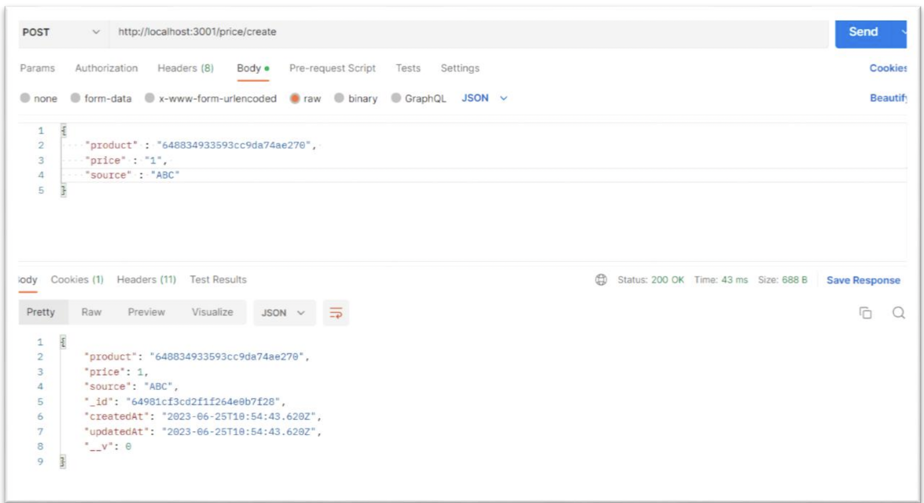

### -Get Price

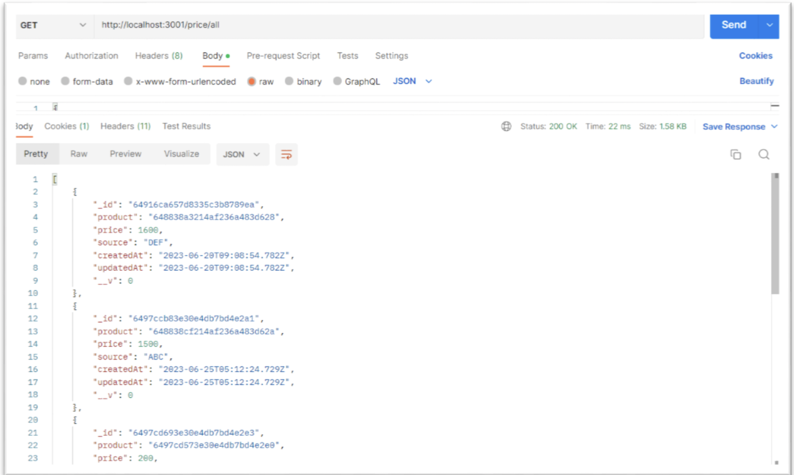

### -Update Price

#### +Before Update

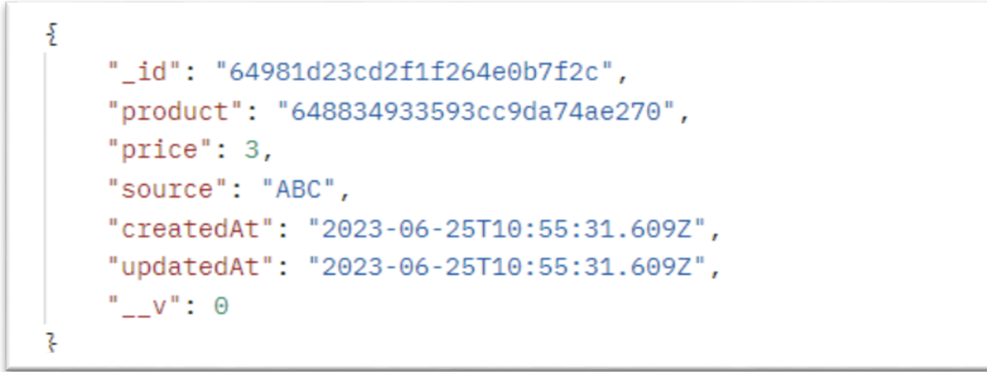

#### + After Update

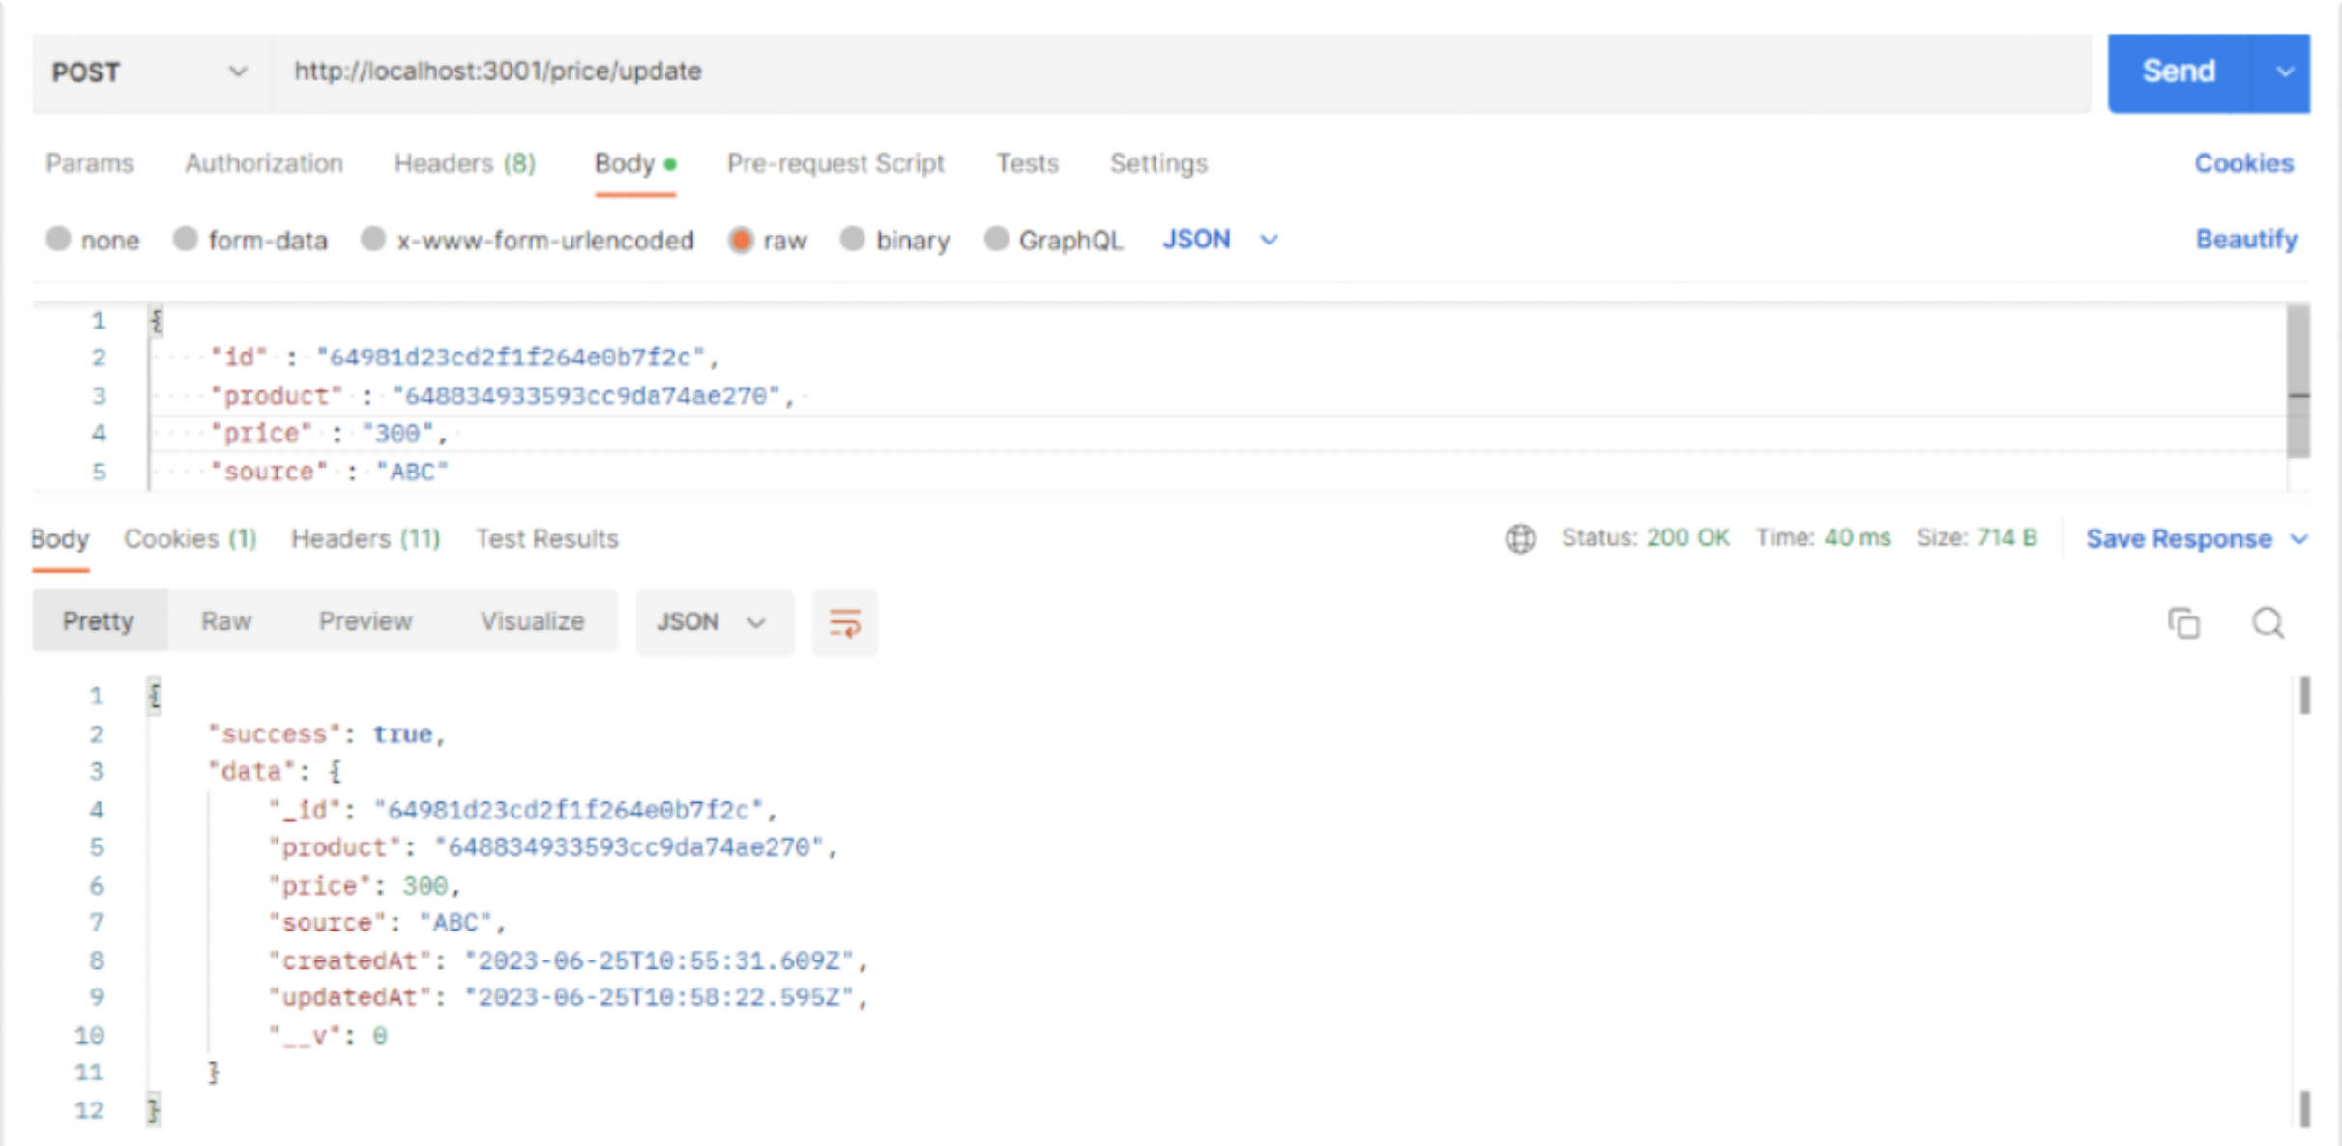

### -Delete Price

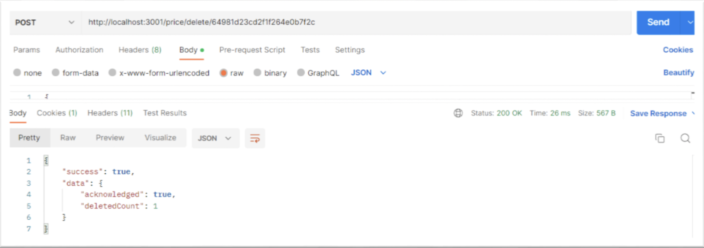

# Exercise 2: VueJS

Design basic admin dashboard to manage a dynamic website

## Login View

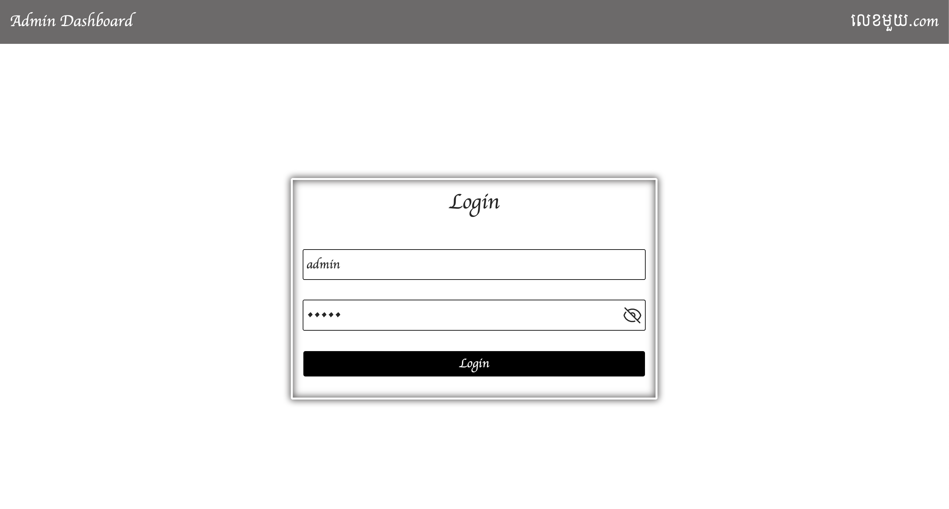

## Management

### Category

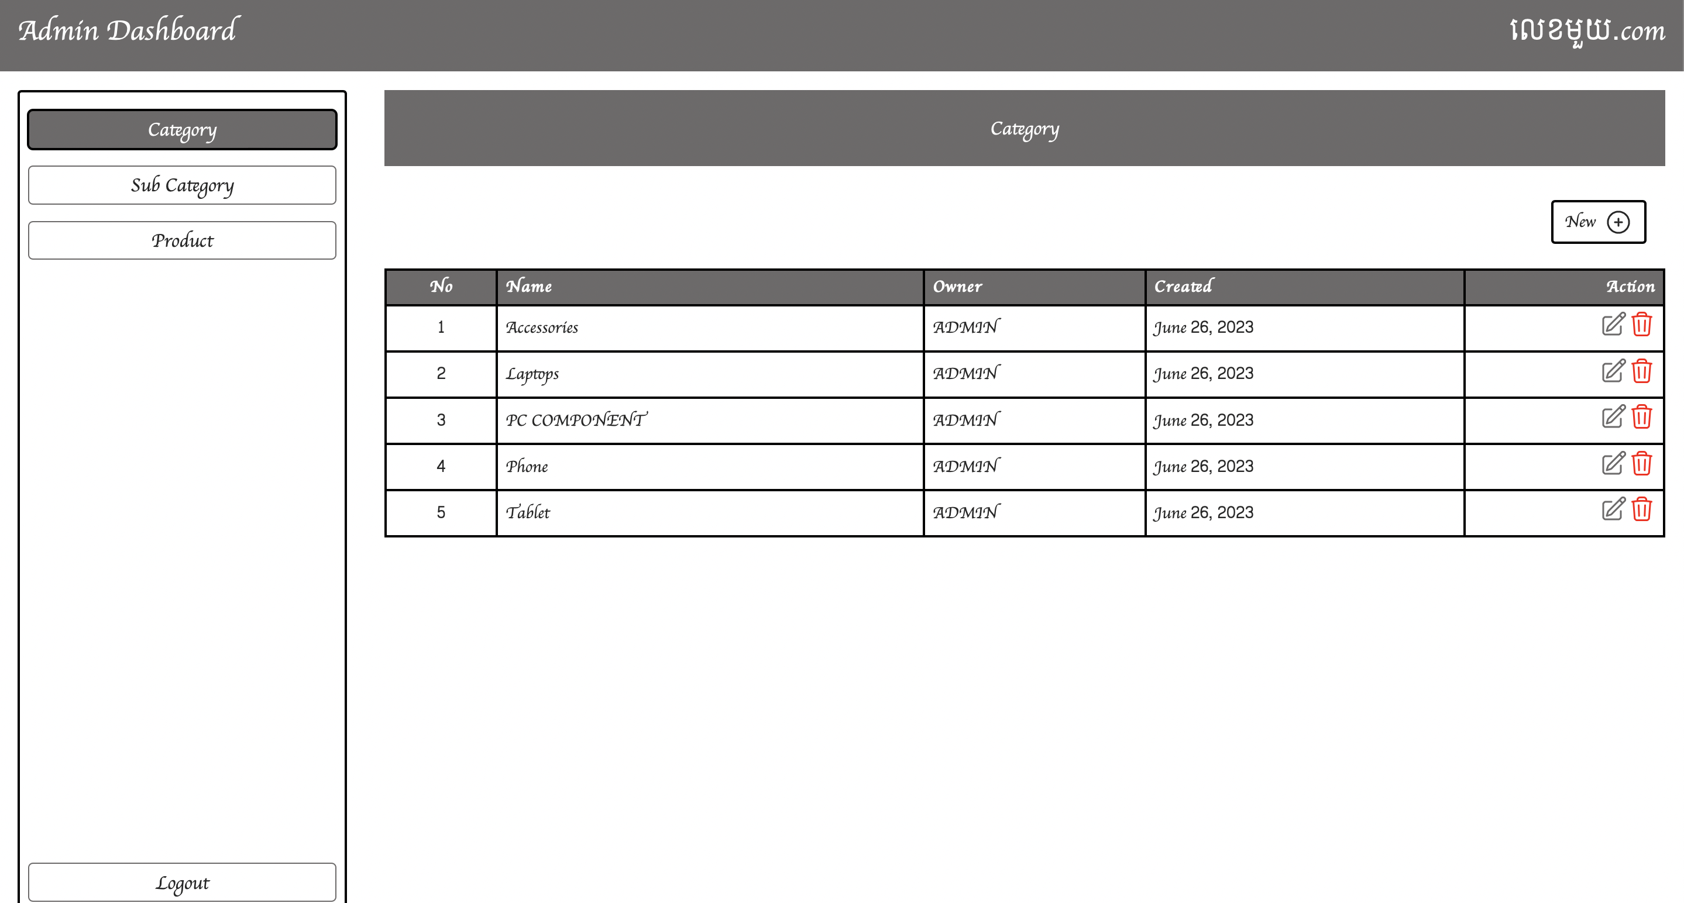

### Sub Category

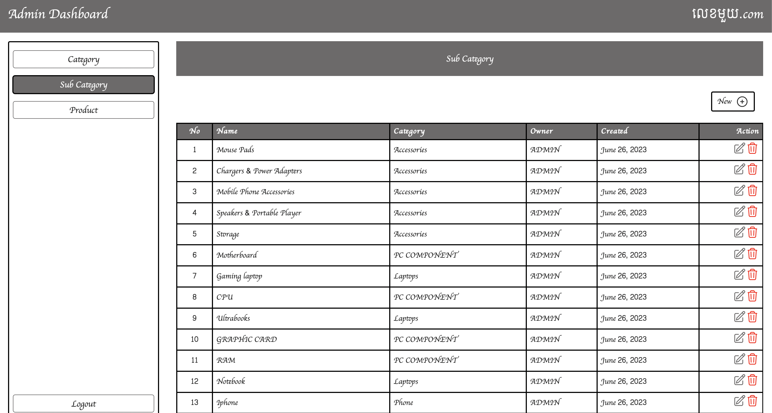

### Product



## Creation

### Category

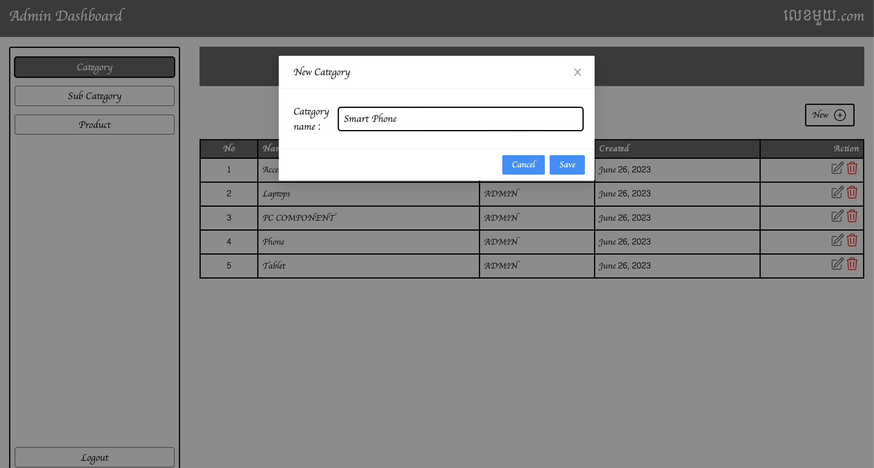

### Sub-Category

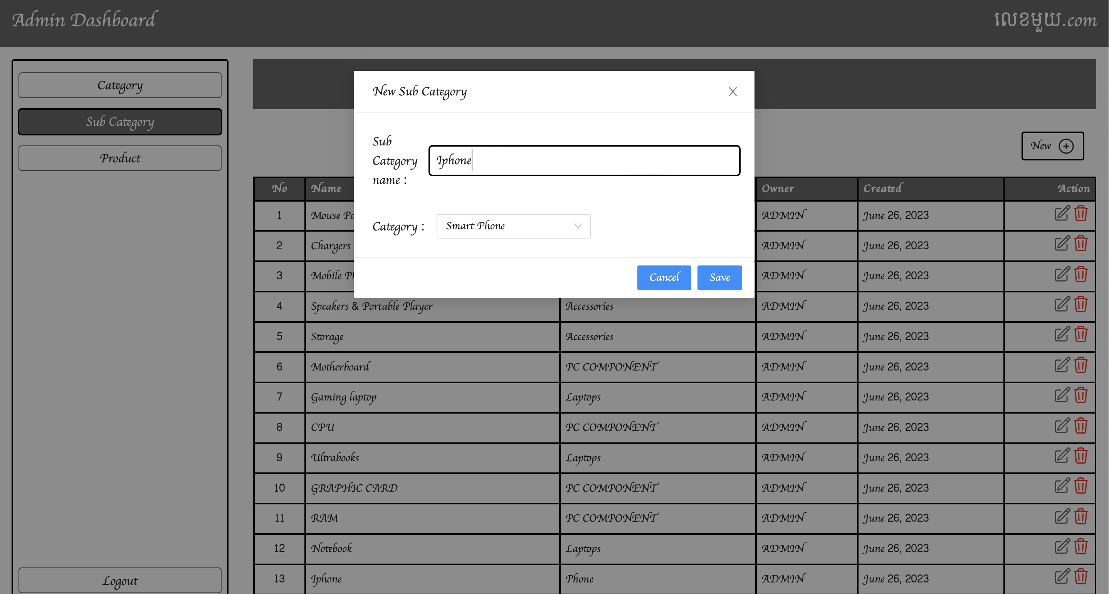

### Product

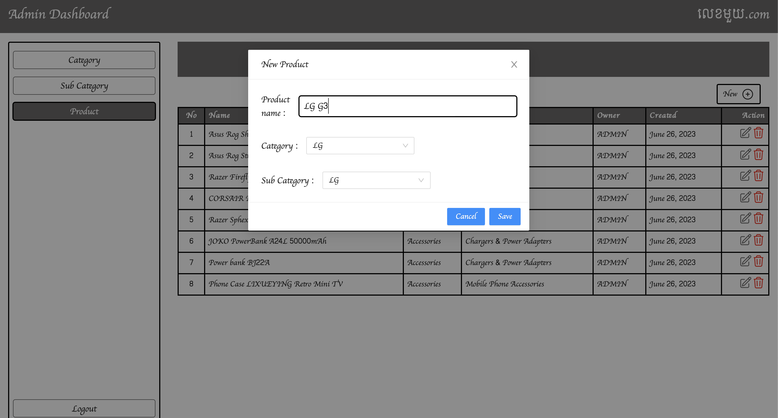

## Update

### Category

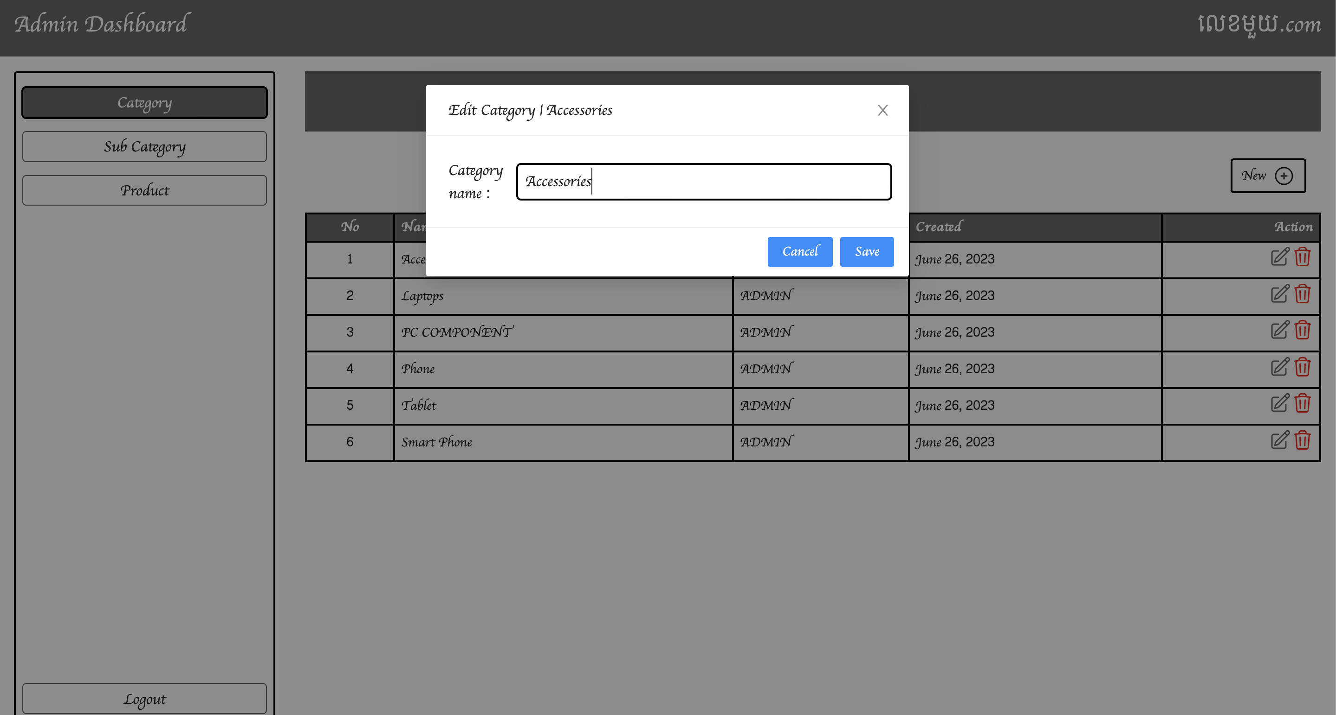

### Sub Category

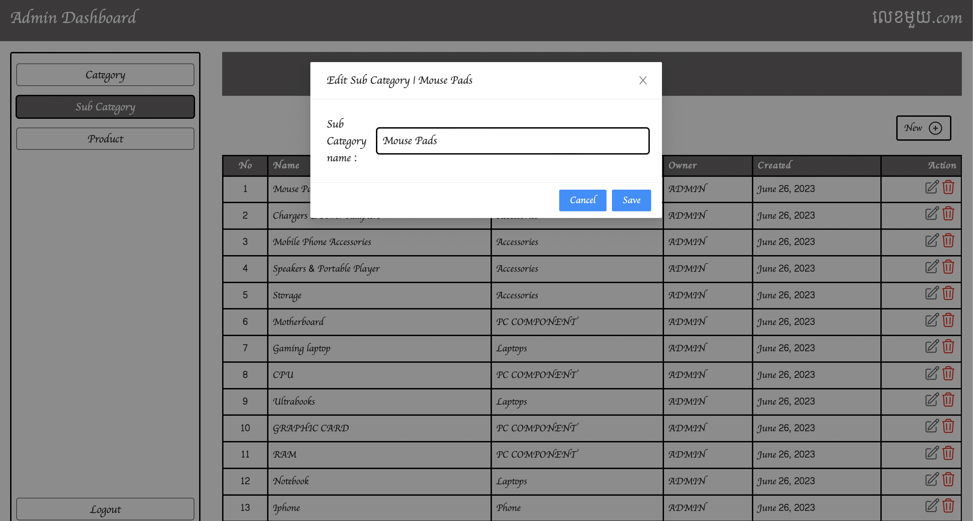

### Product

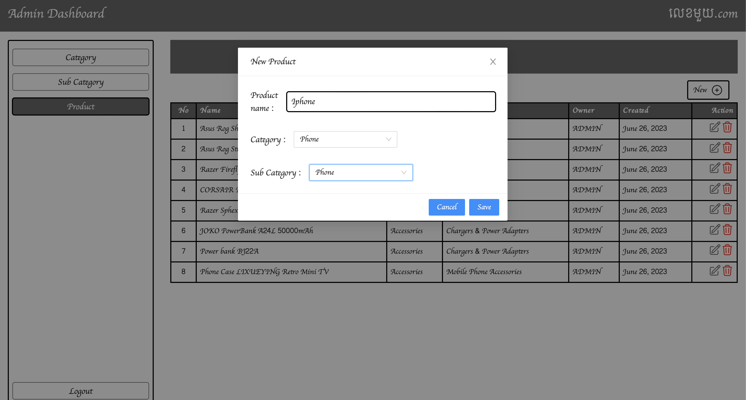

## Delete

### Category

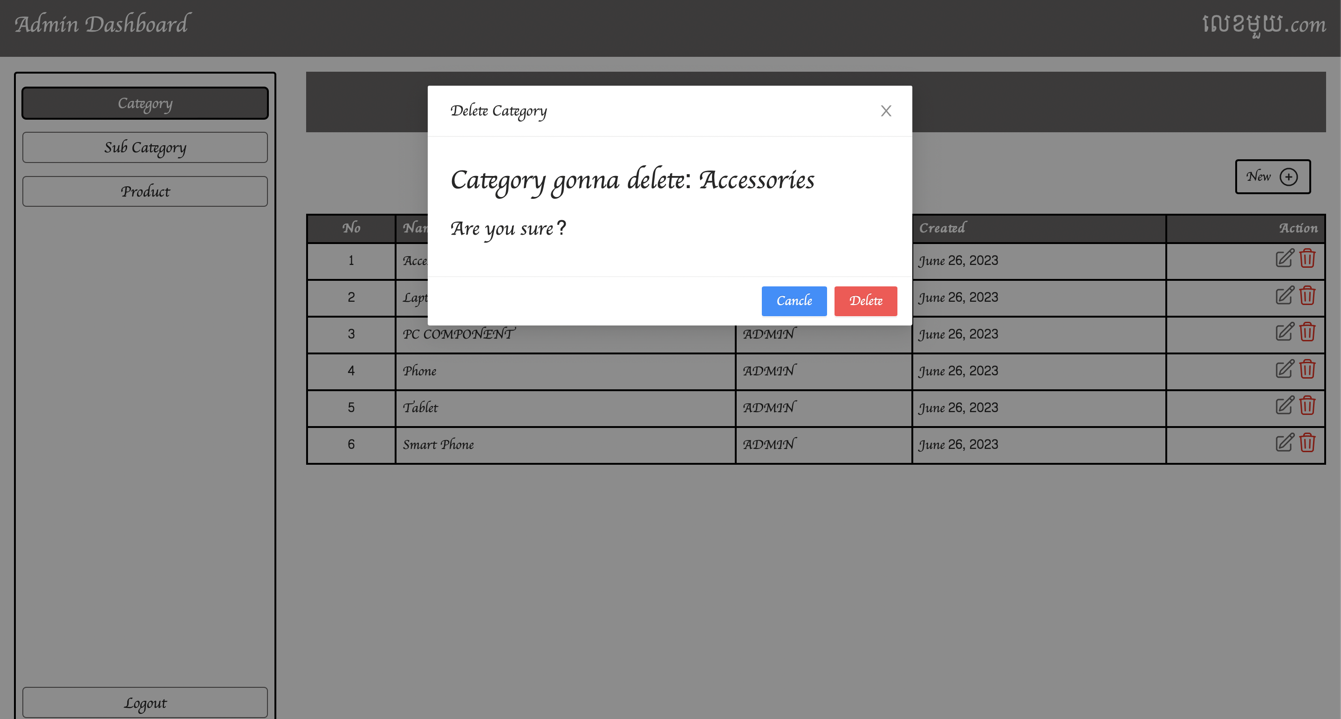

### Sub Category

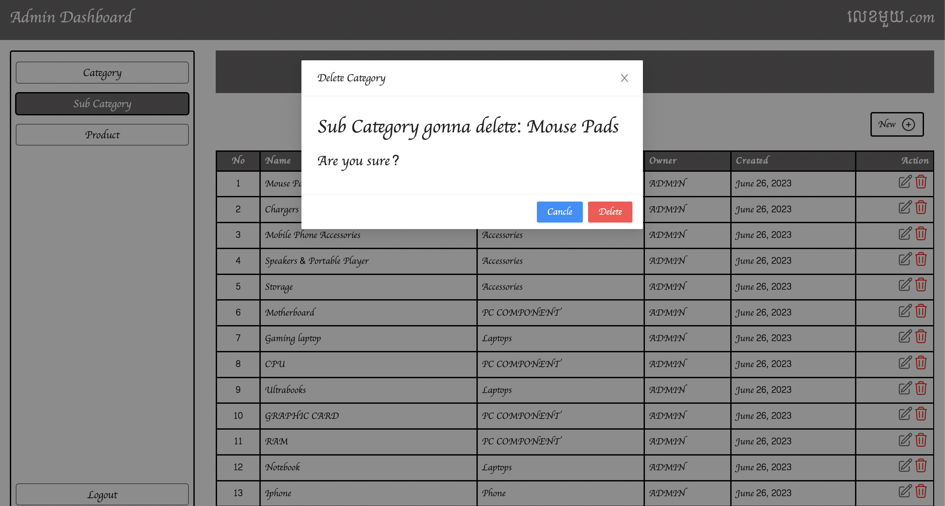

### Product

